**EXPERIMENT-08**

QUES 1: Write a program to create orphan process.



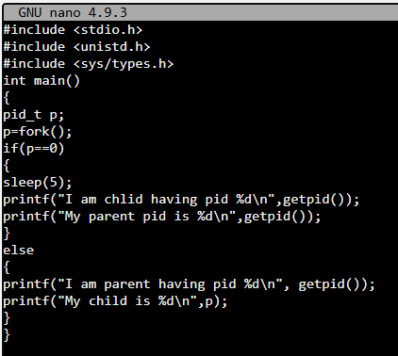

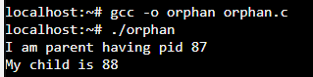

QUES 2: Write a program to create zombie process



